POWERPOINT PRESENTATION
States Project

Interactive National Map Presentation:
*Download a blank National Map off the internet (will do in class) or find an appropriate national map online that identifies the state boundaries, but does not give the state name. This is a presentation on 10 states of your choice. Your map can be in color (as seen below) or with no color but MUST be blank with no state names.
(EX). Click here for link or this link (these links offer two different national maps.

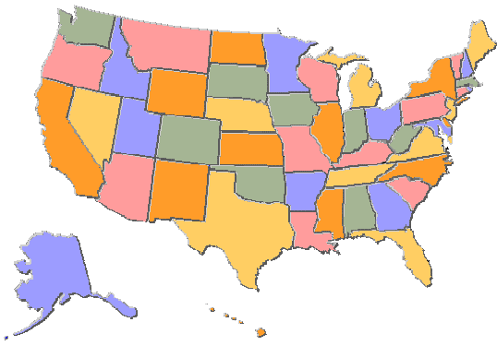
Slide 1 – Insert a national image as your background
- Use your AutoShapes to draw boxes onto the map.
- Double click on the AutoShapes to change the color from blue to “No Fill”
- Right click on the AutoShape and set the hyperlink to the appropriate slide

Slide 2 – Set up the slide as a state of your choice
You must six items on each slide (examples below).
You can add your own ideas, but you do need six items.
The website, 50 states (.com) offers you all of the information you will need as well as other options to
choose from.

State Bird State Flower State Flag State Tree
State Nickname State Capitol State Fish State Monument

Slides 3-11 should have the same information for whichever state you choose.

Master Slide –
Go to – VIEW – Master – slide master
Set three buttons on the bottom of the Master Slide
- Home button – link to slide 1
- Quiz button – link to slide 12 (the quiz slide)
- End button – link to end show

Slide 12 – The Quiz Slide/Page
This slide will use the Control Toolbox which accesses Visual Basic within PowerPoint
Click on View – Toolbars – Control Toolbox
Enable the Title Box on the Control Toolbox Toolbar

